Problem Assignment #3
Control Signals Logic
ECE 2330 Digital Logic Design
Spring 2022
February 25, 2022
By Kevin Moody (km4ws)

Table of Contents
1 Problem Statement 2
2 Analytical Design 3
3 Numerical Verification 5
4 Summary 6

Table of Figures
Figure 1: Simple CPU Architecture 2
Table 1: Simple CPU Control Signals 2
Table 2: Arithmetic Functions Defined by F0 and F1 2
Figure 2: Outer Circuit for Control Signals Logic 3
Figure 3: Inner Circuit for Control Signals Logic 3
Figure 4: Instruction Sequencing and Control Signals 4
Figure 5: Boolean Equations for Inputs and Outputs 4
Figure 6: Test Vector Results 5

1 Problem Statement
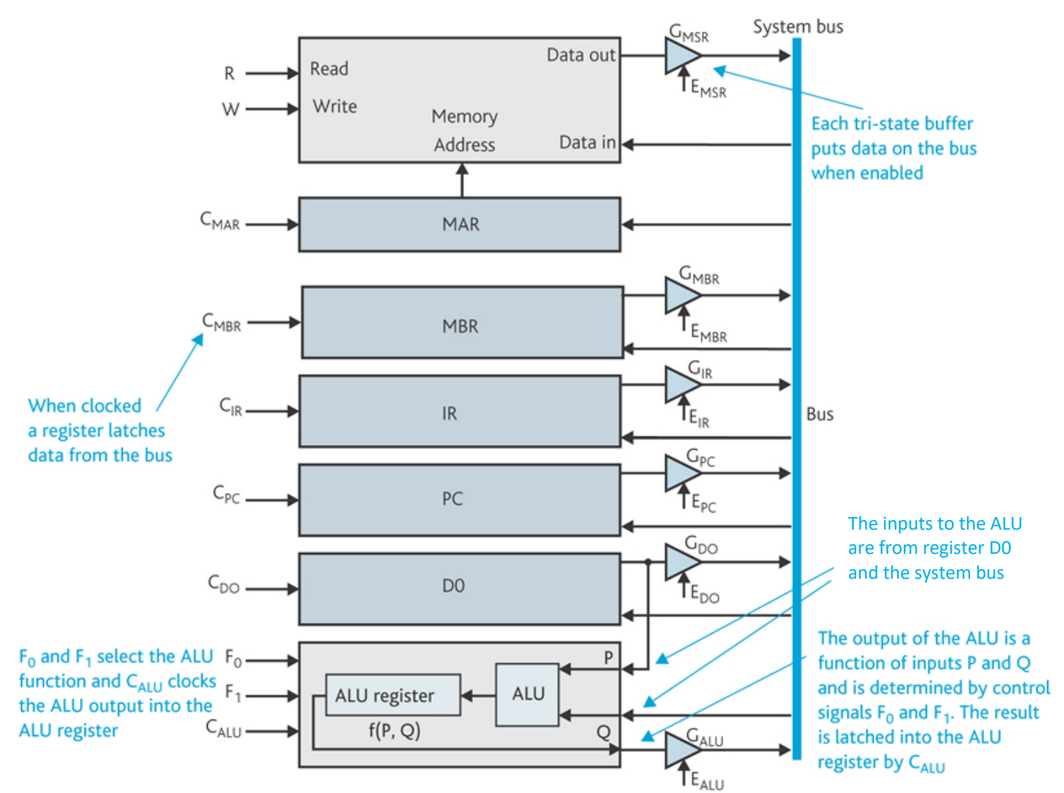
Design circuits to generate the control signals for the Central Processing Unit (CPU) architecture shown in Figure 1. The signals are listened in Table 1, and the arithmetic operations defined by F0 and F1 are listed in Table 2.
Figure 1: Simple CPU Architecture

The architecture contains the Memory Address Register (MAR), the Memory Buffer Register (MBR), the Memory Buffer Register (MBR), the Instruction Register (IR), the Program Counter (PC), Data register D0, an Arithmetic and Logic Unit (ALU), and an ALU register.
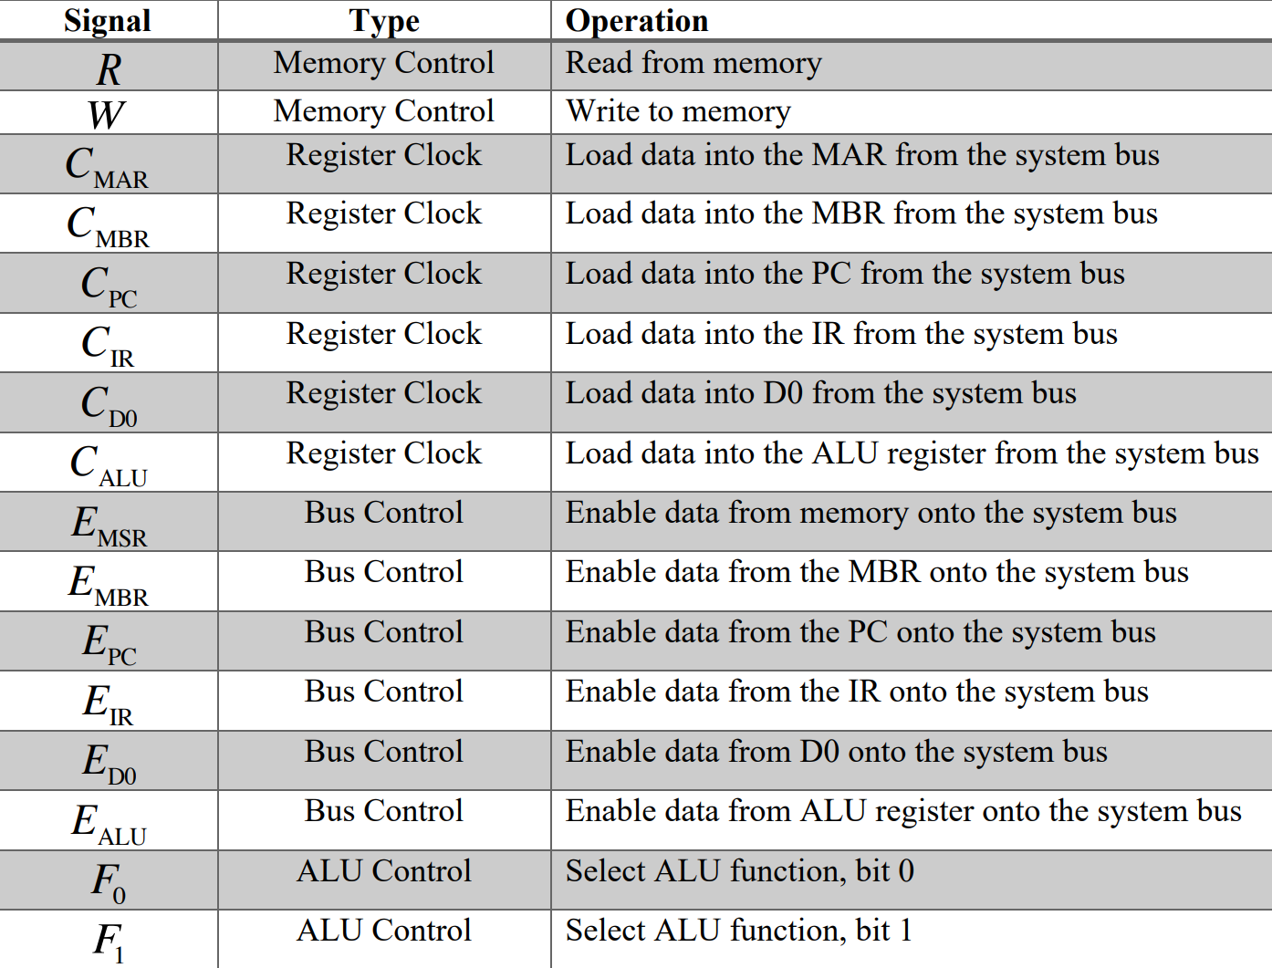
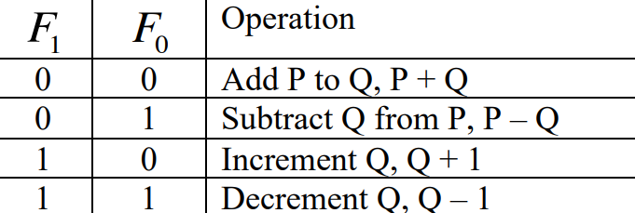
Table 2: Arithmetic Functions Defined by F0 and F1

Table 1: Simple CPU Control Signals
2 Analytical Design
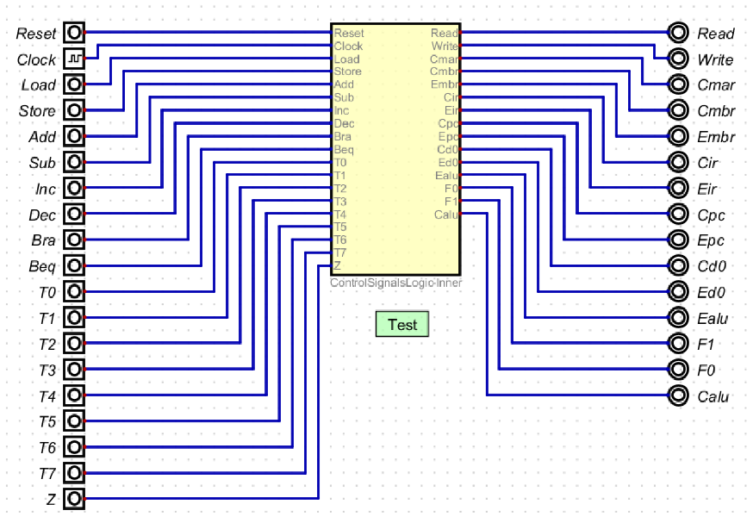
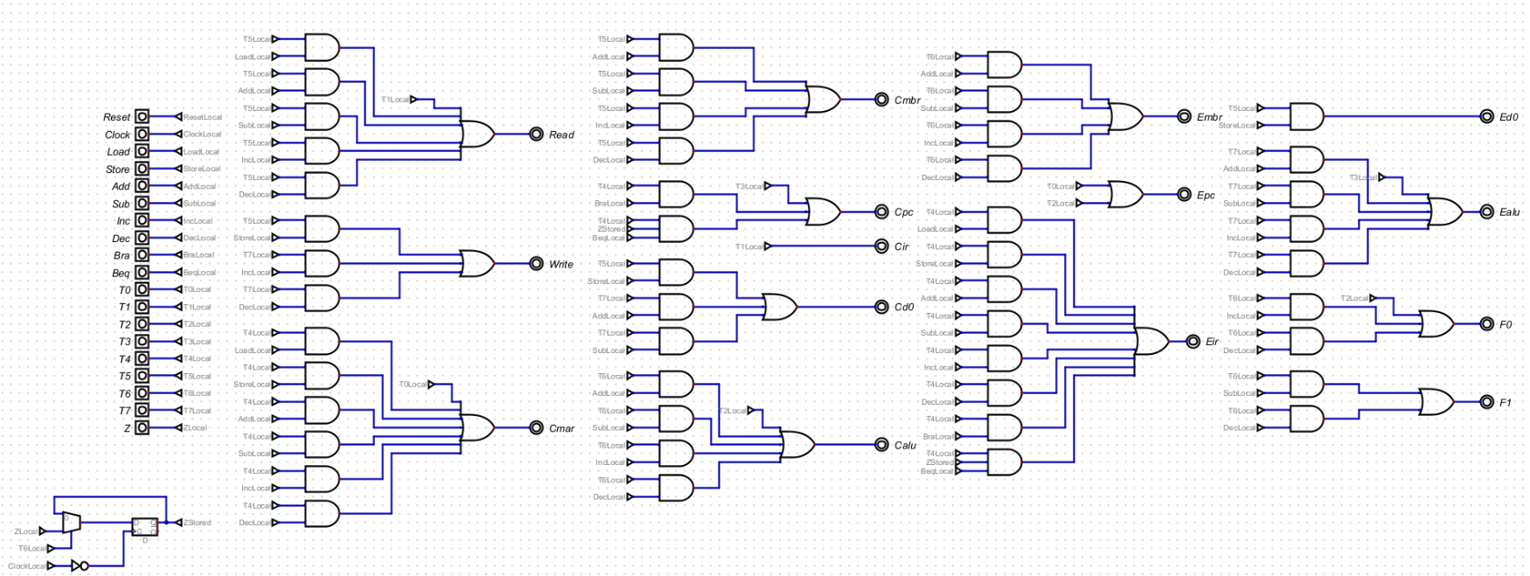
The outer and inner circuit schematics for the Control Signals Logic are shown in Figures 2 and 3 respectfully. The yellow box in the outer circuit contains the schematic shown in the inner circuit.
Figure 3: Inner Circuit for Opcode Decoder
Figure 2: Outer Circuit for Controls Signals Logic

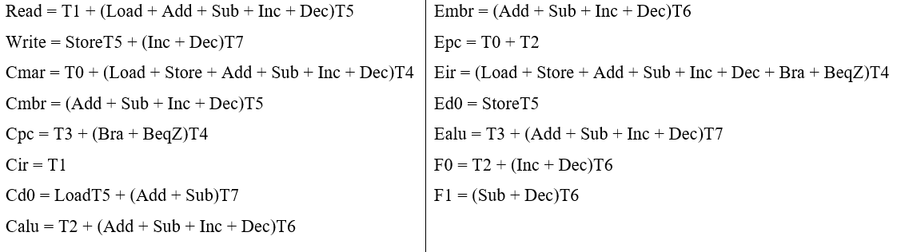
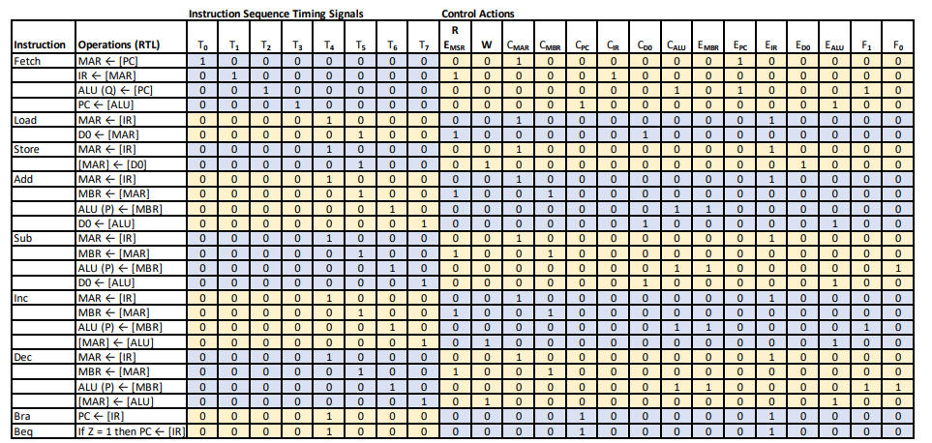
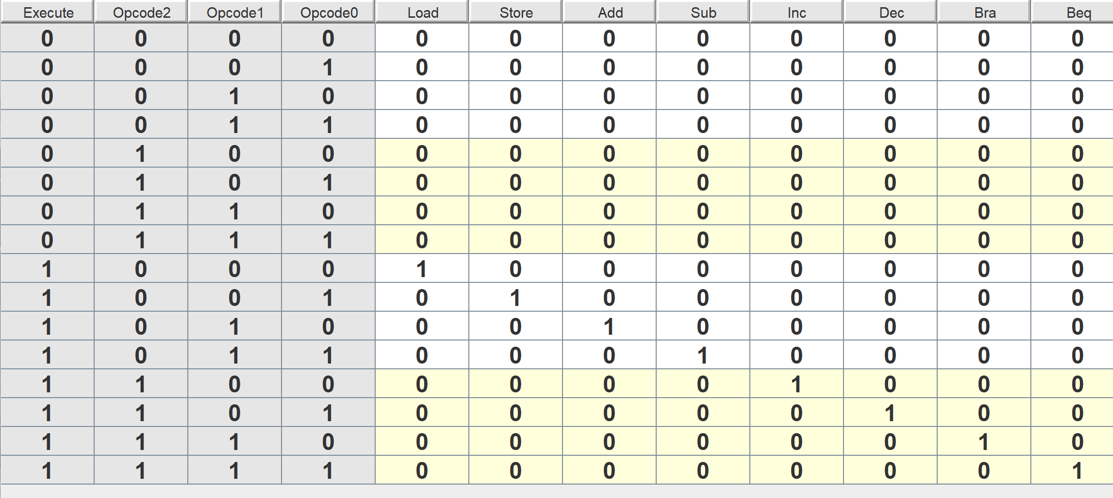
Below shown in Figure 4 is the Instruction Sequencing and Control Signals truth table / chart, which was used to create this circuit design. By combining the instruction on the left, with the T value given, and a set Control Action output, we were able to create Boolean expressions for each instruction, as simplified and shown in Figure 5.
Figure 5: Boolean Equations for Inputs and Outputs
Figure 4: Instruction Sequencing and Control Signals
Figure 4: Truth Table for Opcode Decoder

3 Numerical Verification
Based off of the complete set of inputs and outputs shown in Figure 4, an exhaustive set of test vectors was created. The number of test vectors combined to 58, where 29 had Clock = 0 and 29 had Clock = 1. From there, there were 25 vectors each to test methods Load, Store, Add, Sub, Inc, Dec, and Bra. Beq required four vectors, where two had Z = 0 and two had Z = 1, as well as changing the inputs for T4 and T6 in order to store a value of Z, and then to check whether or not the value was correctly stored (or not stored). The verification for this data is shown in Figure 6. The list of test vectors themselves has not been included for brevity, but can be seen in ControlSignalsLogic.dig file.
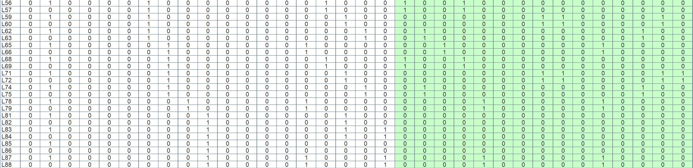
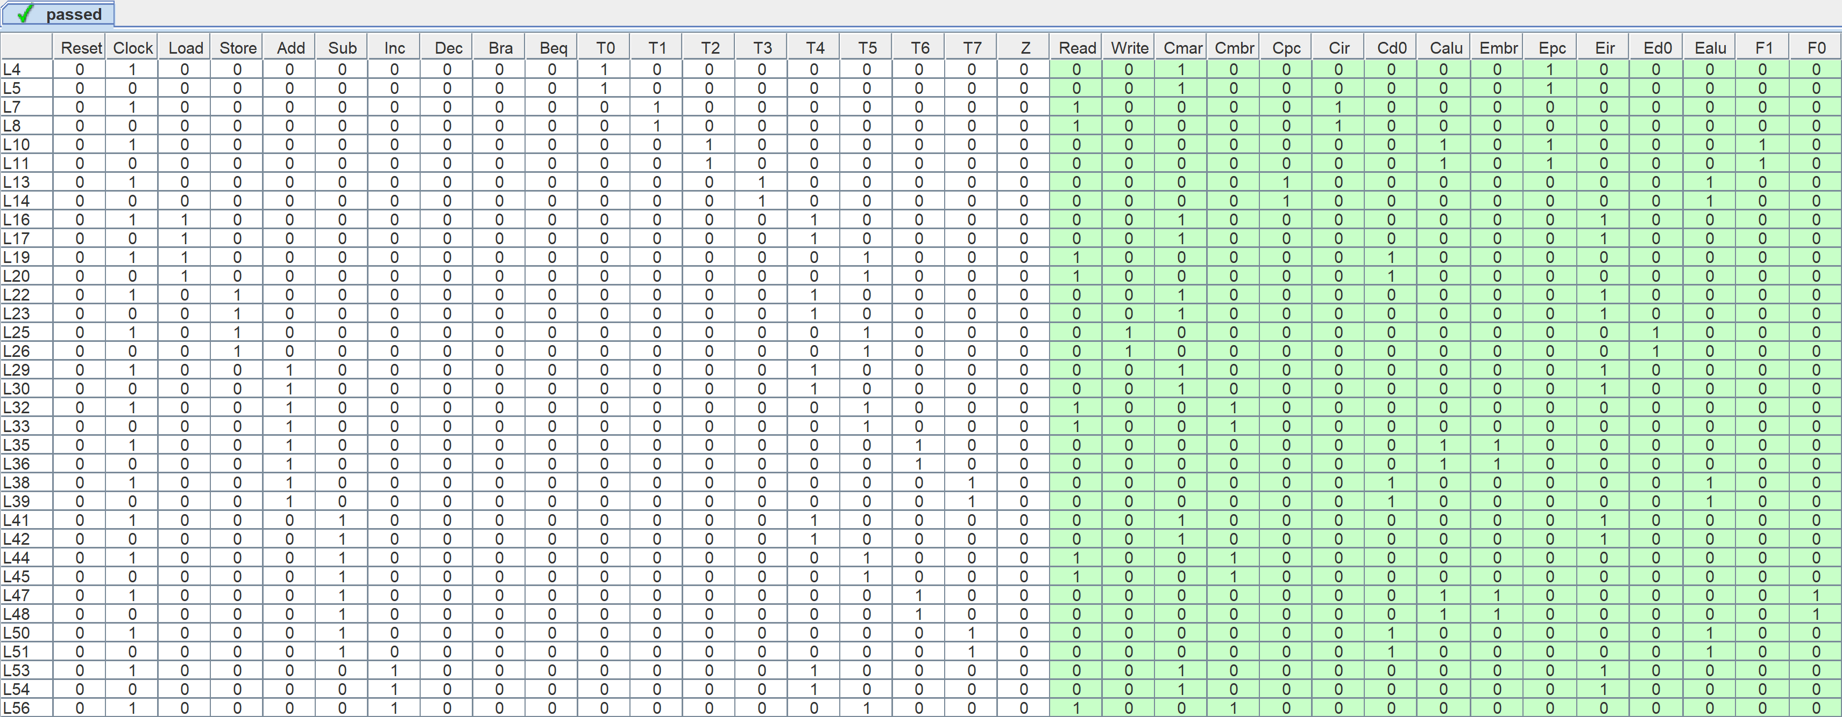
4 Summary
Figure 6: Test Vector Results
The problem requirement for this assignment was to design circuits to generate control signals for the Central Processing Unit. This was done by combining the use of tunnels, AND, and OR gates to create an easy-to-read circuit that successfully takes in two inputs (an instruction and a T value) and will output CPU signals.
A truth table was used to develop a list of possible solutions for the Control Signals Logic, which was then used to design a digital circuit solution. The circuit solution was then tested with an exhaustive set of input test vectors (58 test vectors, 29 each for Clock = 0 and 1), and produced the expected output for each test vector. Therefore, the digital circuit design solution satisfies the problem requirements.

